LAB-3

In this case, we are going to check MapReduce java programming.

We have to create an input directory. Because, we have to import our file on there. For that, we need to use put command and give an absolute path name. I want to save the BILLAH file into another file using mapreduce.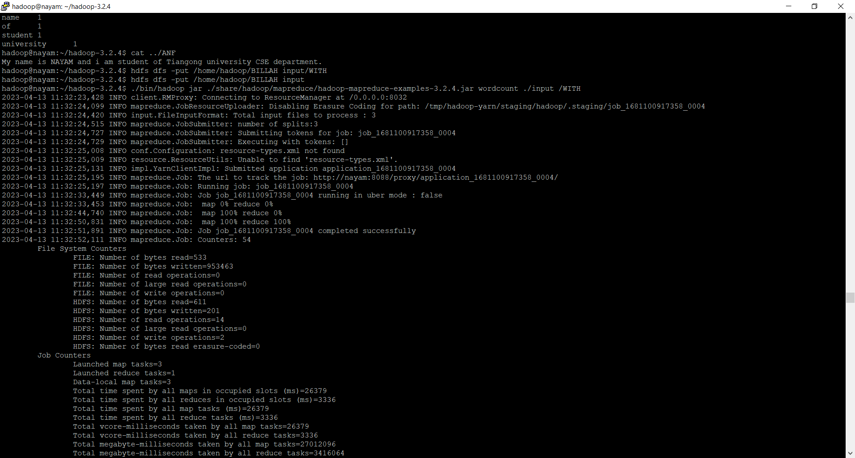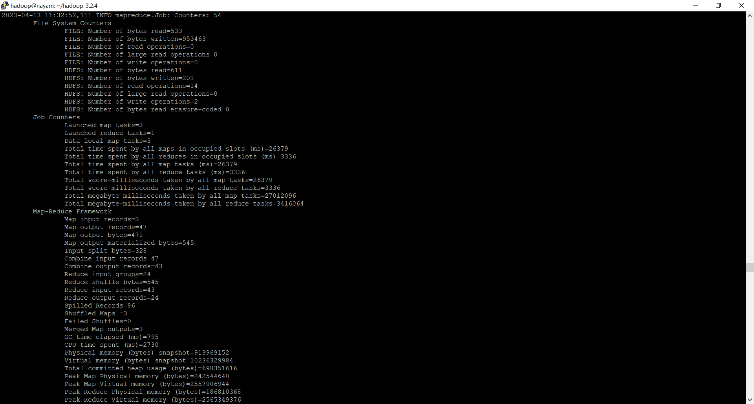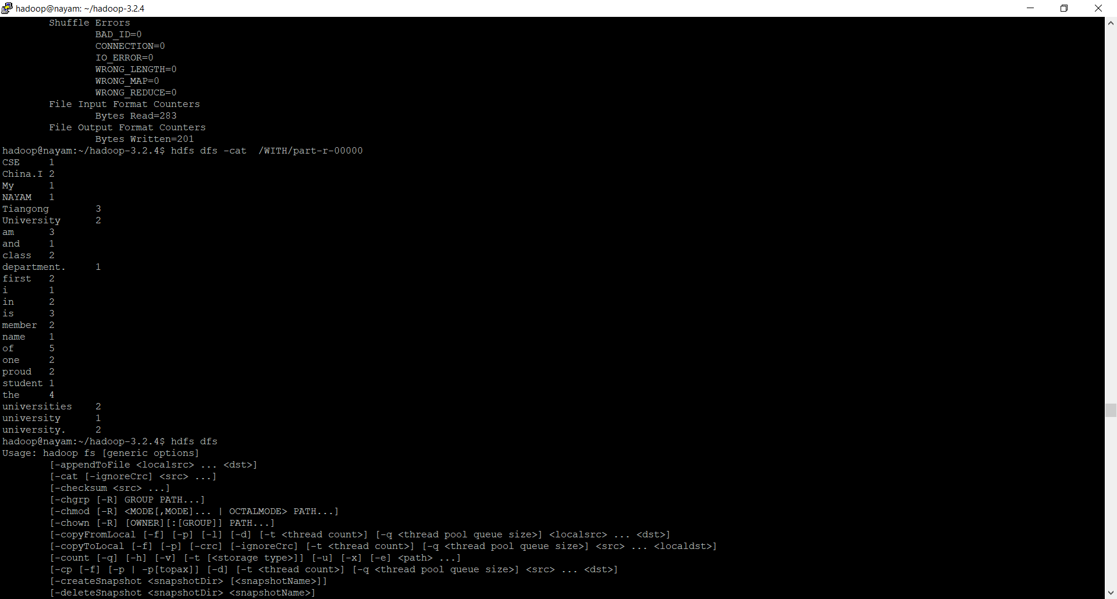

If we look at the system then we can see that , first of all, we created a directory for importing the file

. In here, we gave a absolute path name which is BILLAH for input is WITH. Now, we have to create another folder which is output folder. No need to put anything here. Once I will run the file using command then the output will be here. The output file name will be executed in a certain directory file. If we go to the browser then we see the output which is part-r-00000.there is one reducer that we used. if we use more reducer then there will be more file on the system. So, this is the output under hadoop ownership read and write file(rw)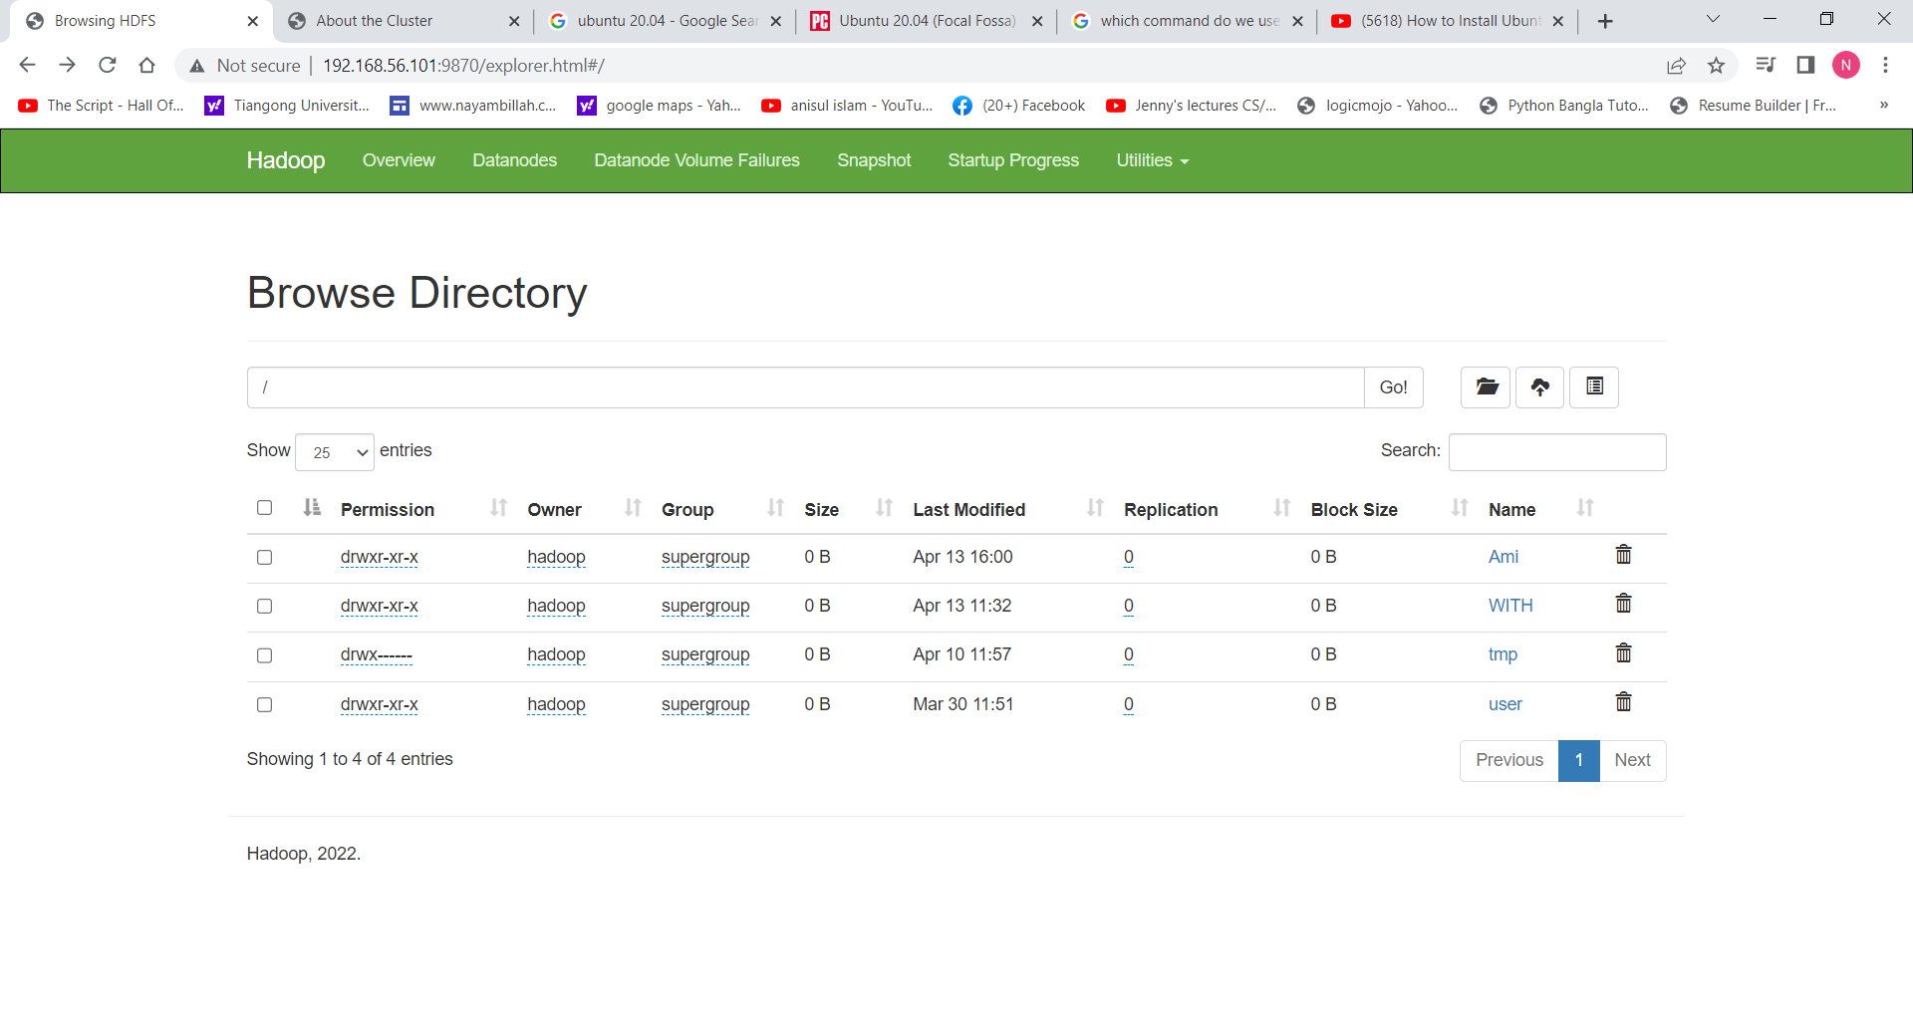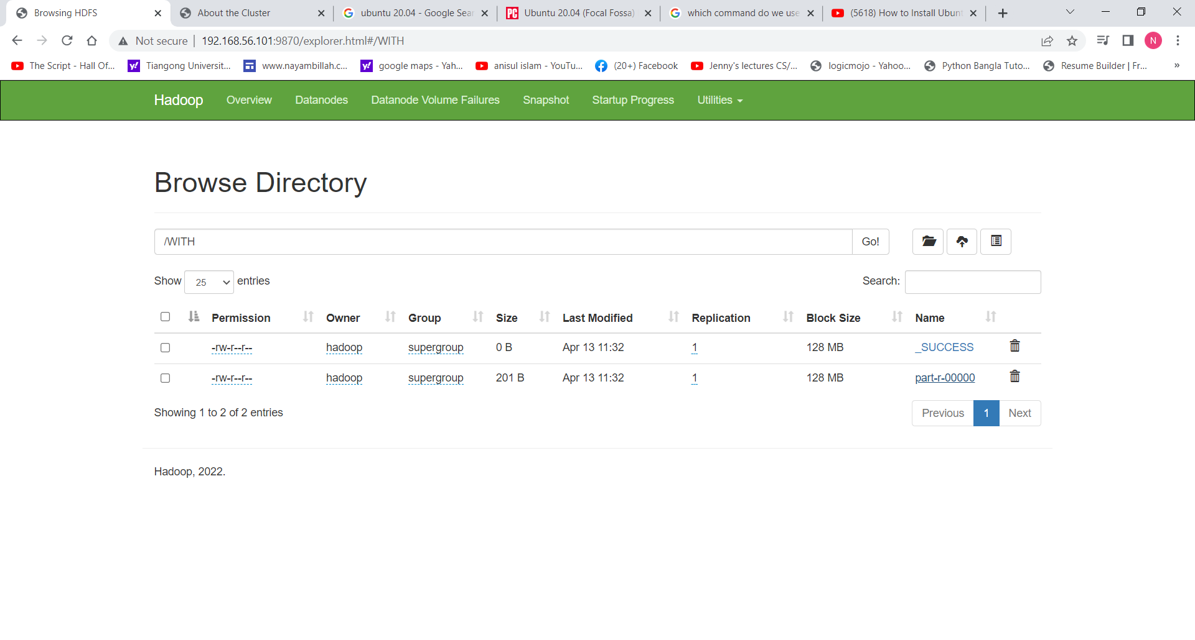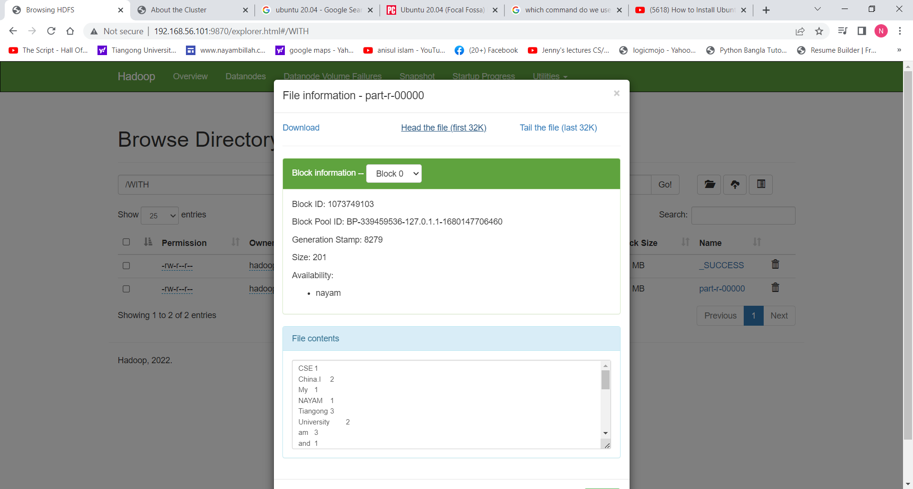

After mapreducing, we got the final output.